**Assignment – 1**

**• Install Power BI Desktop and share the final screenshot of the report view page which appears when power desktop starts.**

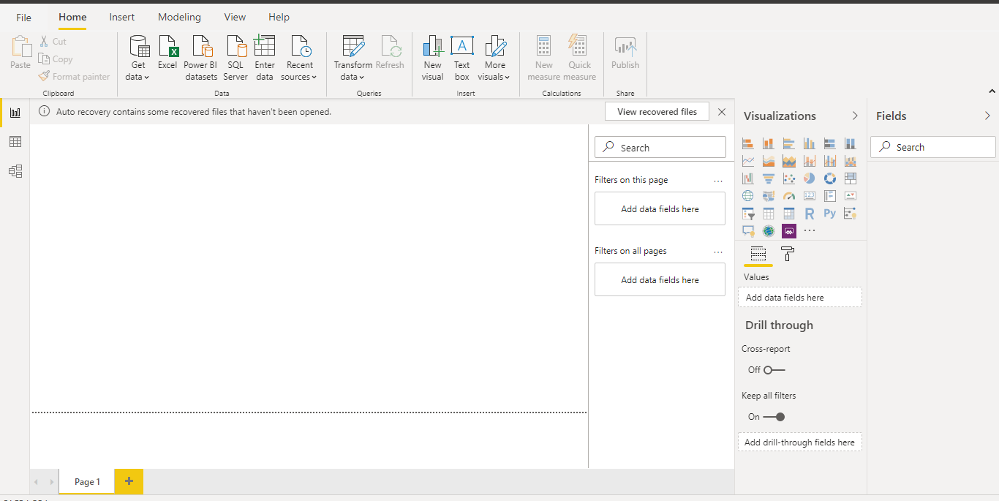

**2. Prepare a document and with the following screenshot − Report View − Data View − Model View − Power Query Editor − Advance Editor ?**

**1.** **Report View −**

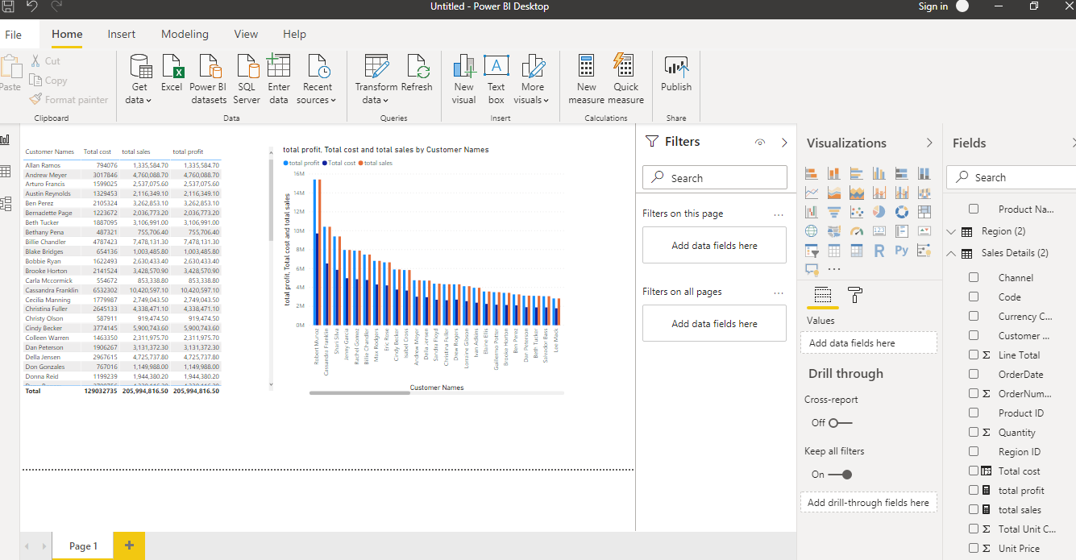

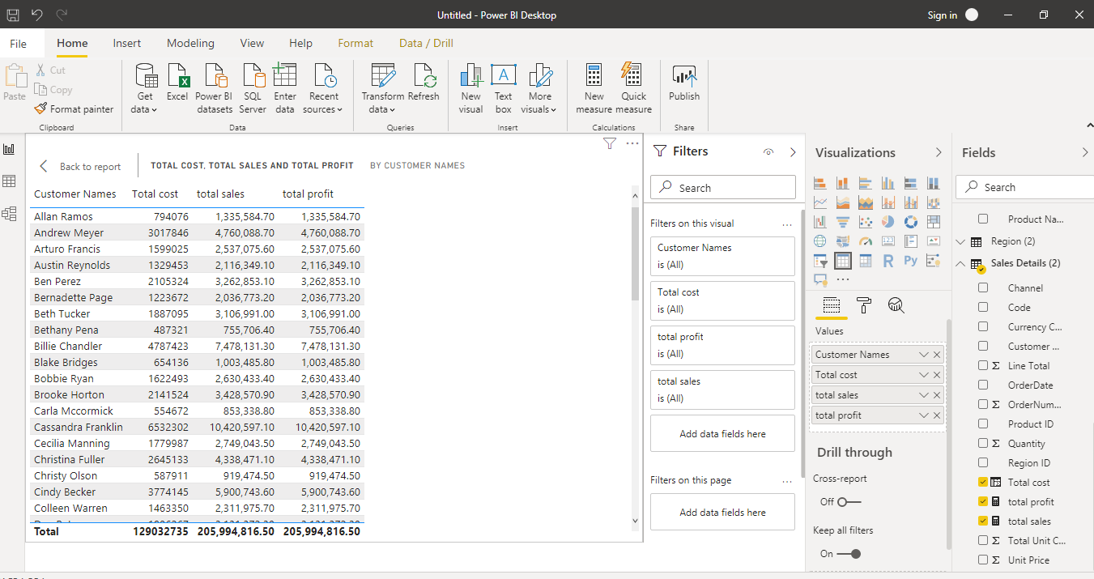

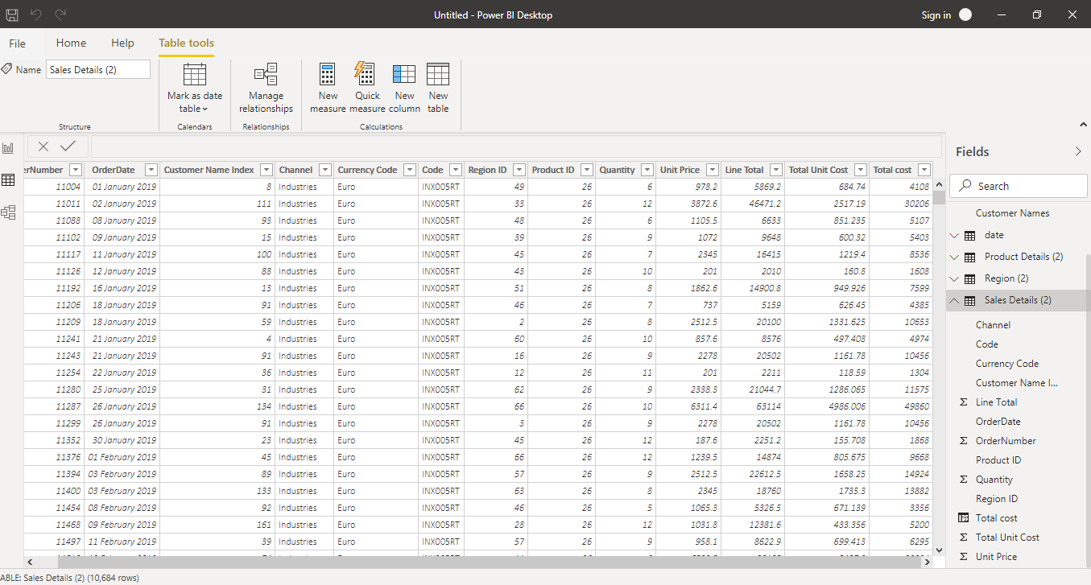**2.Data View :**

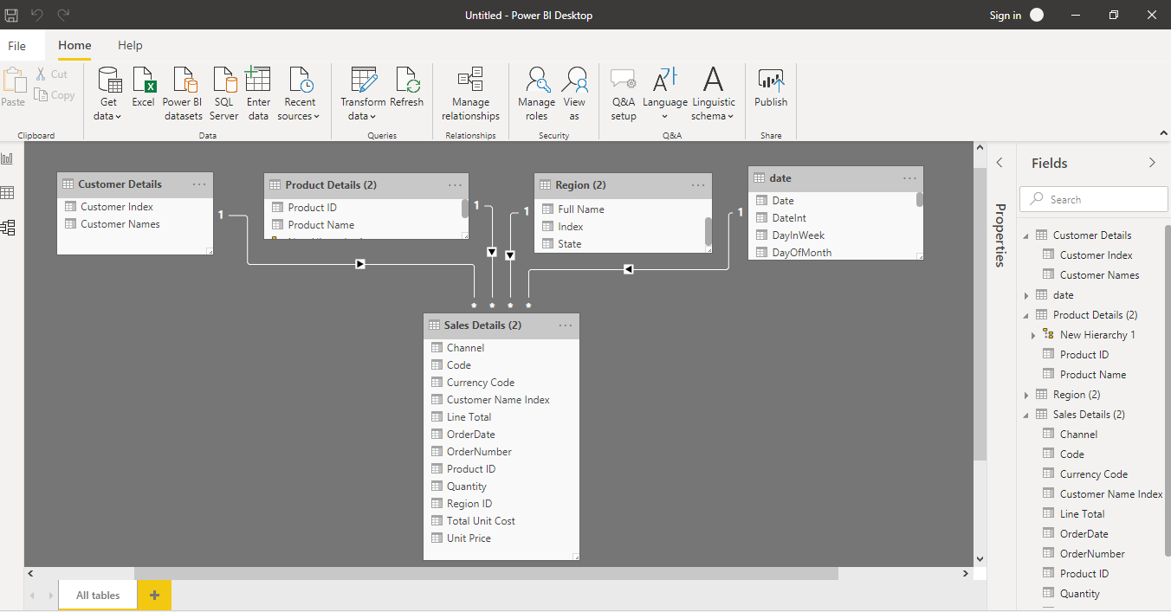**3. Model View :**

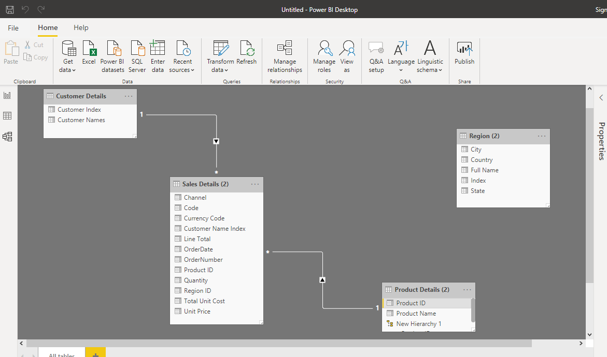

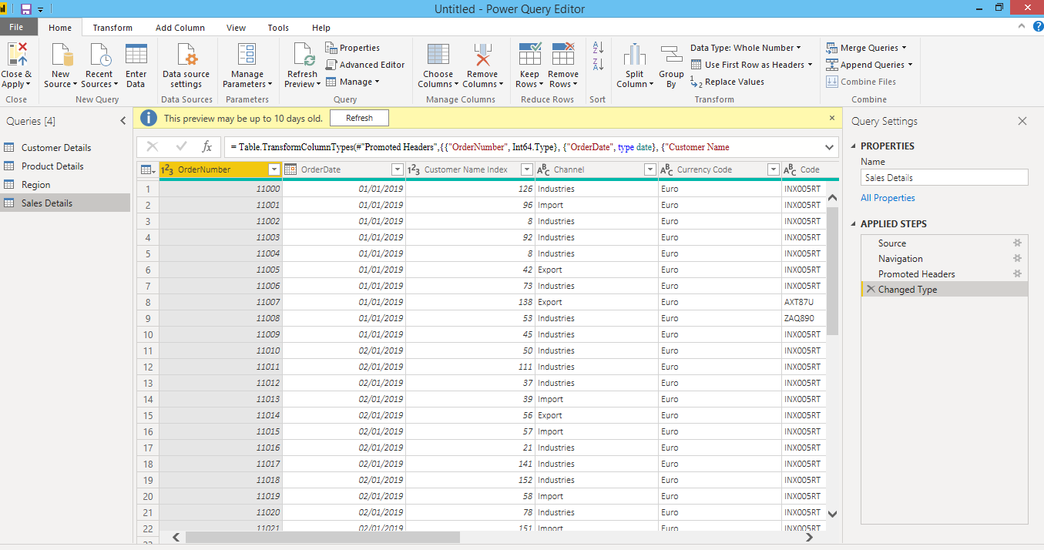**4. Power Query Editor :**

**5. Advance Editor :**

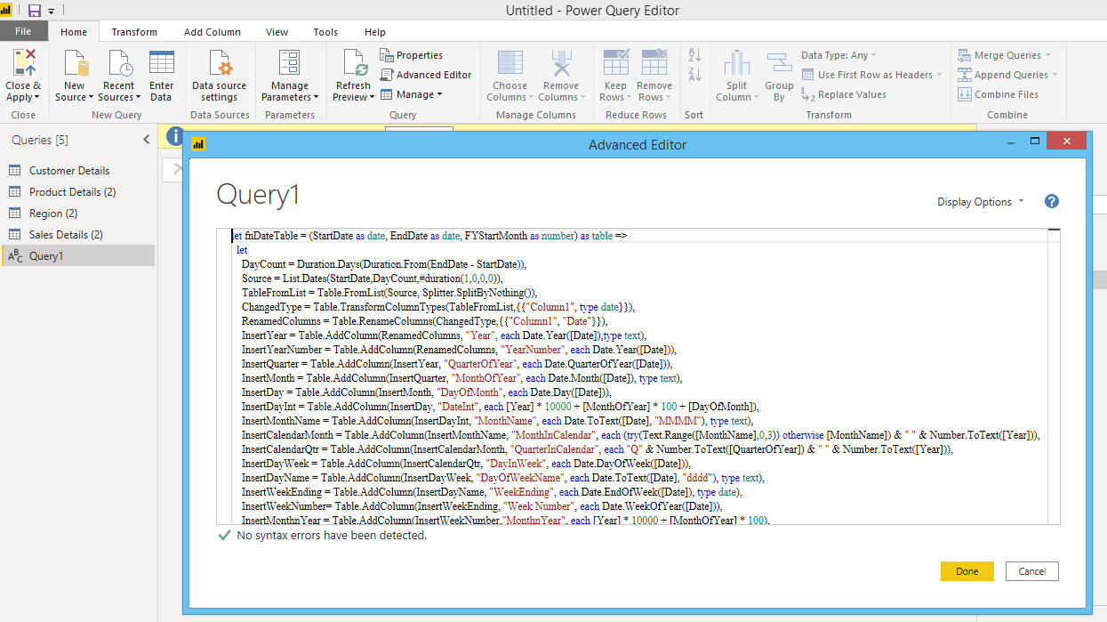

**3. Prepare a document with details of the following along with their price**

**− Power BI Desktop − Power BI Pro − Power BI Premium**

1. **Power BI Desktop −**

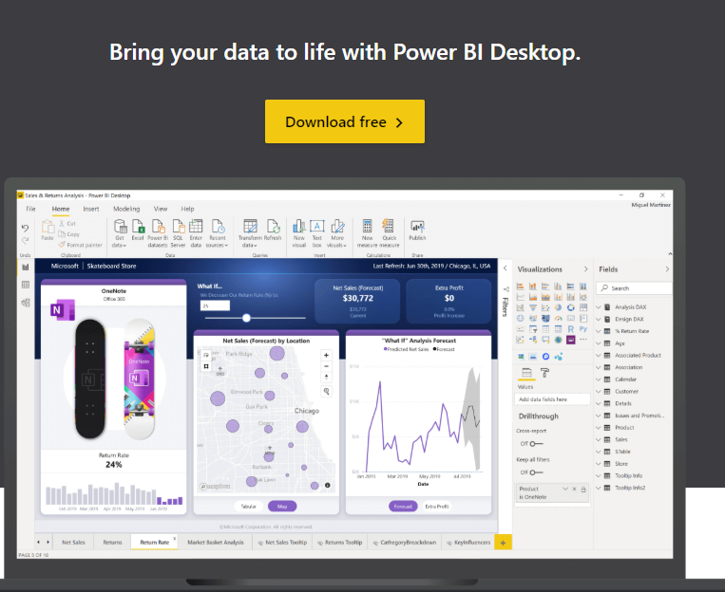

**2. Power BI Pro**

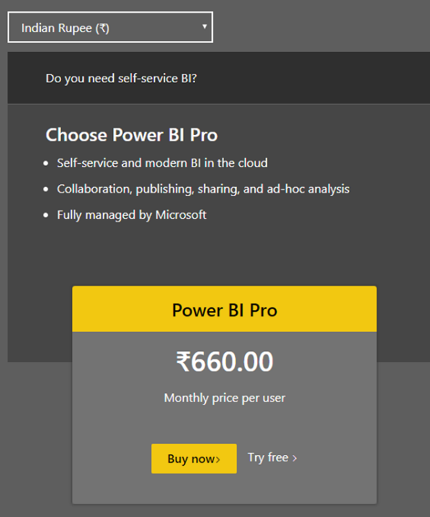

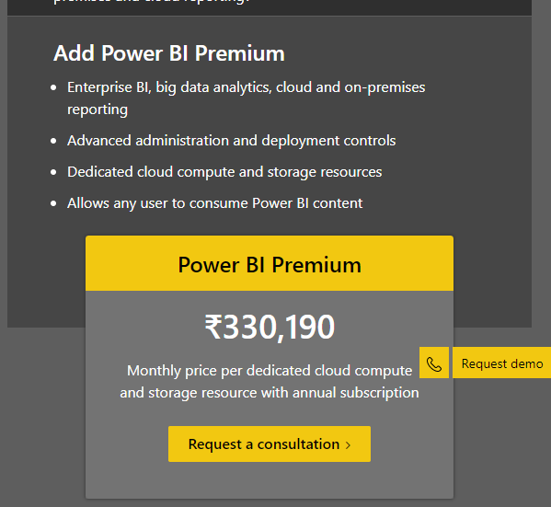**3.Power BI Premium**